НИЖЕГОРОДСКИЙ ГОСУДАРСТВЕННЫЙ ТЕХНИЧЕСКИЙ

УНИВЕРСИТЕТ

ИМ. Р.Е. АЛЕКСЕЕВА

Кафедра "Вычислительные системы и технологии"

**ПРОГРАММИРОВАНИЕ**

**Отчёт**

**по лабораторной работе № 3**

Массивы и векторная память.

Использование статических массивов в языке С++

Вариант № 20

Выполнил студент группы 19-ИВТ-3

Сухоруков Валерий Алексеевич

«3»ноября 2019 г.

Проверил ст. преподаватель кафедры ВСТ

Мартынов Д.С.

«___» _______ 2019 г.

Нижний Новгород 2019

Программы на языке С++

№1(Вывод и на консоль и в файл)

#include <fstream>

#include <iostream>

#include <cmath>

#include <iomanip>

const double e = 2.7182818284;

char logo[] = "*********************************************************\n"

"* Nizhniy Novgorod Technical University *\n"

"* Study work number 3. Task number 1. *\n"

"* Performed student 19-IVT-3 Sukhorukov V.A. *\n"

"*********************************************************\n";

using namespace std;

int main()

{

ofstream os("result.txt");

os << logo<< "y=x^3+e^(x+1)" << endl;

cout << logo << "y=x^3+e^(x+1)" << endl;

double f[41][2];

f[0][1] = (-4.0) * (-4.0) * (-4.0) + pow(e, -3.0);

double yMax = f[0][1], yMin = f[0][1], j = -4.0;

for (int i = 0; i < 41; i++)

{

f[i][0] = j * j * j + pow(e, j + 1.0);

f[i][1] = j;

if (f[i][0] > yMax) { yMax = f[i][0]; }

if (f[i][0] < yMin) { yMin = f[i][0]; }

os << "i=" << setw(2) << i << " x[i]=" << setw(5) << setprecision(1) << fixed << f[i][1] << " y[i]=" << setw(9) << setprecision(4) << fixed << f[i][0] << endl;

cout << "i=" << setw(2) << i << " x[i]=" << setw(5) << setprecision(1) << fixed << f[i][1] << " y[i]=" << setw(9) << setprecision(4) << fixed << f[i][0] << endl;

j = j + 0.1;

}

os << "yMax= " << yMax << " yMin= = " << yMin << endl;

cout << "yMax= " << yMax << " yMin= = " << yMin << endl;

os.close();

return 0;

}

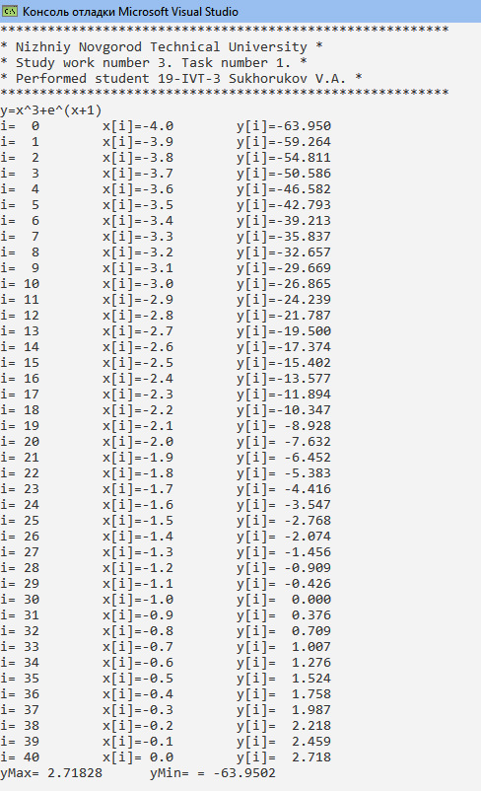

В задачах №2-№26 используется функция проверки числа на правильность ввода. В целях экономии ресурсов я пропишу её 1 раз.

int proverkaN(){

int n = 0;

char b = 1;

while (cin.good()) {

if (n == 0) {

cout << "write array size ";

while (b != 0)

{

b = cin.get();

if (b >= '0' && b <= '9')

{

n = n * 10 + (b - 48);

}

else {

if (b != '\n')

{

cout << "error, write again " << endl;

n = 0;

}

else

{

break;

}

}

}

}

else {

break;

}

}

return n;}

№2

#include <iostream>

#include <vector>

char logo[] = "*********************************************************\n"

"* Nizhniy Novgorod Technical University *\n"

"* Study work number 3. Task number 2. *\n"

"* Performed student 19-IVT-3 Sukhorukov V.A. *\n"

"*********************************************************\n";

using namespace std;

int main()

{

cout << logo;

int n = proverkaN(),k=0;

vector<int> a(n);

for (int i = 0; i < n; i++) {

cout << "write array element ";

cin >> a[i];

if (a[i] == 0) {

k++;

}

}

cout <<"number of zero elements = "<< k<<endl;

return 0;

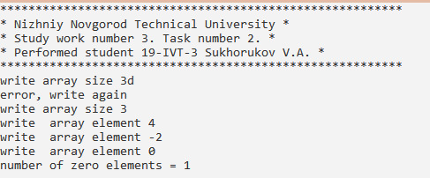}

№3

#include <iostream>

#include <vector>

char logo[] = "*********************************************************\n"

"* Nizhniy Novgorod Technical University *\n"

"* Study work number 3. Task number 3. *\n"

"* Performed student 19-IVT-3 Sukhorukov V.A. *\n"

"*********************************************************\n";

using namespace std;

int main()

{

cout << logo;

int n = proverkaN(), s = 0;

vector<int> a(n);

for (int i = 0; i < n; i++) {

cout << "write array element ";

cin >> a[i];

if ( (i + 1) % 2 == 1) {

s = s + a[i];

}

}

cout << "sum (i + 1) % 2 == 1 = " << s << endl;

return 0;

}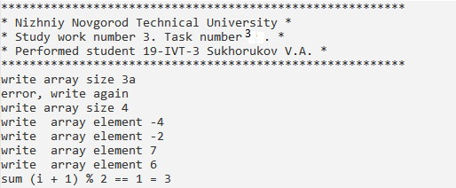

№4

#include <iostream>

#include <vector>

char logo[] = "*********************************************************\n"

"* Nizhniy Novgorod Technical University *\n"

"* Study work number 3. Task number 4. *\n"

"* Performed student 19-IVT-3 Sukhorukov V .A. *\n"

"*********************************************************\n";

using namespace std;

int main()

{

cout << logo;

int n = proverkaN(), p = 1;

vector<int> a(n);

for (int i = 0; i < n; i++) {

cout << "write array element ";

cin >> a[i];

if (a[i] < 0) {

p=p*a[i];

}

}

if (p == 1) {

cout << " no elements that contain negative values " << endl;

}

else {

cout << "product of elements containing negative values = " << p << endl;

}

return 0;

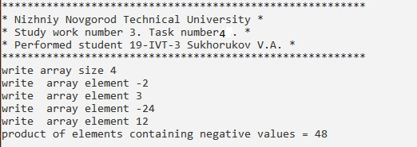}

№5

#include <iostream>

#include <vector>

char logo[] = "*********************************************************\n"

"* Nizhniy Novgorod Technical University *\n"

"* Study work number 3. Task number 5. *\n"

"* Performed student 19-IVT-3 Sukhorukov V.A. *\n"

"*********************************************************\n";

using namespace std;

int main()

{

cout << logo;

int n = proverkaN(), p = 0;

vector<int> a(n);

for (int i = 0; i < n; i++) {

cout << "write array element ";

cin >> a[i];

if (a[i] < 0) {

p = p + a[i];

}

}

cout << "sum of elements containing negative values = " << p << endl;

return 0;

}

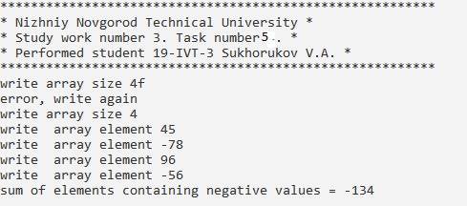

№6

#include <iostream>

#include <vector>

char logo[] = "*********************************************************\n"

"* Nizhniy Novgorod Technical University *\n"

"* Study work number 3. Task number 6. *\n"

"* Performed student 19-IVT-3 Sukhorukov V.A. *\n"

"*********************************************************\n";

using namespace std;

int main()

{

cout << logo;

int n = proverkaN(), p = 0;

vector<int> a(n);

for (int i = 0; i < n; i++) {

cout << "write array element ";

cin >> a[i];

if (a[i] == 1) {

p++;

}

}

cout << "number of units in the array = " << p << endl;

return 0;

}

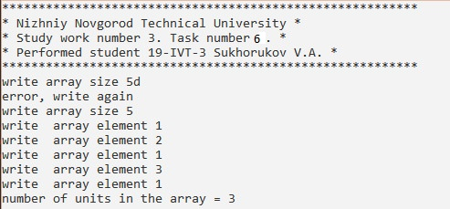

№7

#include <iostream>

#include <vector>

char logo[] = "*********************************************************\n"

"* Nizhniy Novgorod Technical University *\n"

"* Study work number 3. Task number 7. *\n"

"* Performed student 19-IVT-3 Sukhorukov V.A. *\n"

"*********************************************************\n";

using namespace std;

int main()

{

cout << logo;

int n = proverkaN(), p = 1;

vector<int> a(n);

for (int i = 0; i < n; i++) {

cout << "write array element ";

cin >> a[i];

if ((i + 1) % 2 == 1) {

p = p * a[i];

}

}

cout << "product of elements at odd places in the array = " << p << endl;

return 0;

}

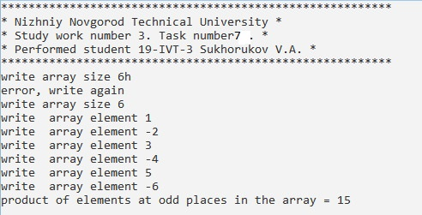

№8

#include <iostream>

#include <vector>

char logo[] = "*********************************************************\n"

"* Nizhniy Novgorod Technical University *\n"

"* Study work number 3. Task number 8. *\n"

"* Performed student 19-IVT-3 Sukhorukov V.A. *\n"

"*********************************************************\n";

using namespace std;

int main()

{

cout << logo;

int n = proverkaN();

float s = 0;

vector<float> a(n);

for (int i = 0; i < n; i++) {

cout << "write array element ";

cin >> a[i];

if (a[i]>1) {

s = s + a[i];

}

}

cout << "sum = " << s << endl;

return 0;

}

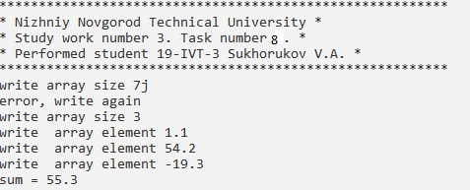

№9

#include <iostream>

#include <vector>

char logo[] = "*********************************************************\n"

"* Nizhniy Novgorod Technical University *\n"

"* Study work number 3. Task number 9. *\n"

"* Performed student 19-IVT-3 Sukhorukov V.A. *\n"

"*********************************************************\n";

using namespace std;

int main()

{

cout << logo;

int n = proverkaN(), k = 0;

vector<float> a(n);

for (int i = 0; i < n; i++) {

cout << "write array element ";

cin >> a[i];

if (a[i] < 1) {

k++;

}

}

cout << "kol-vo chisel <1 = " << k << endl;

return 0;

}

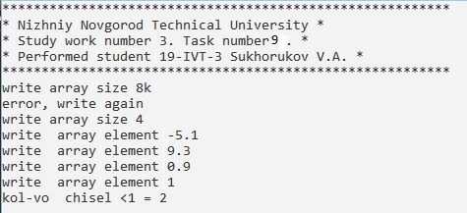

№10

#include <iostream>

#include <vector>

char logo[] = "*********************************************************\n"

"* Nizhniy Novgorod Technical University *\n"

"* Study work number 3. Task number 10. *\n"

"* Performed student 19-IVT-3 Sukhorukov V.A. *\n"

"*********************************************************\n";

using namespace std;

int main()

{

cout << logo;

int n = proverkaN();

float p = 1.0;

vector<float> a(n);

for (int i = 0; i < n; i++) {

cout << "write array element ";

cin >> a[i];

if (a[i] > 2) {

p = p * a[i];

}

}

cout << "proizvedenie >2 = " << p << endl;

return 0;

}

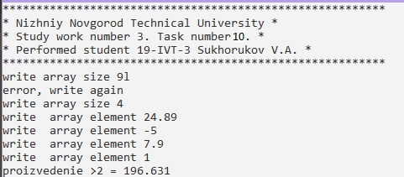

№11

#include <iostream>

#include <vector>

char logo[] = "*********************************************************\n"

"* Nizhniy Novgorod Technical University *\n"

"* Study work number 3. Task number 11. *\n"

"* Performed student 19-IVT-3 Sukhorukov V.A. *\n"

"*********************************************************\n";

using namespace std;

int main()

{

cout << logo;

int n = proverkaN();

float s = 0;

vector<float> a(n);

for (int i = 0; i < n; i++) {

cout << "write array element ";

cin >> a[i];

if ((i+1)%3==0) {

s = s + a[i];

}

}

cout << "sum for i%3==0 = " << s << endl;

return 0;

}

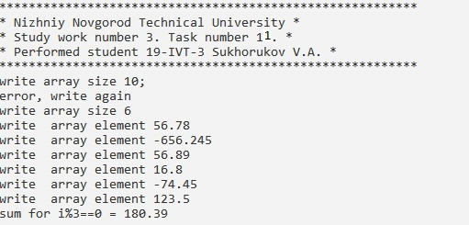

№12

#include <iostream>

#include <vector>

char logo[] = "*********************************************************\n"

"* Nizhniy Novgorod Technical University *\n"

"* Study work number 3. Task number 12. *\n"

"* Performed student 19-IVT-3 Sukhorukov V.A. *\n"

"*********************************************************\n";

using namespace std;

int main()

{

cout << logo;

int n = proverkaN();

float p = 1.0;

vector<float> a(n);

for (int i = 0; i < n; i++) {

cout << "write array element ";

cin >> a[i];

if (a[i]<=2) {

p=p*a[i];

}

}

cout << "product for a[i]<=2 = " << p << endl;

return 0;

}

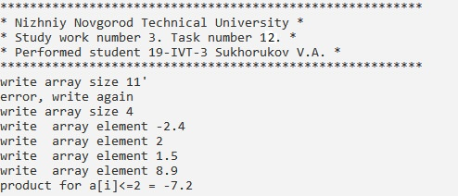

№13

#include <iostream>

#include <vector>

char logo[] = "*********************************************************\n"

"* Nizhniy Novgorod Technical University *\n"

"* Study work number 3. Task number 13. *\n"

"* Performed student 19-IVT-3 Sukhorukov V.A. *\n"

"*********************************************************\n";

using namespace std;

int main()

{

cout << logo;

int n = proverkaN(), k = 0;

vector<int> a(n);

for (int i = 0; i < n; i++) {

cout << "write array element ";

cin >> a[i];

if (a[i] == 3 || a[i]==5) {

k++;

}

}

cout << "kol-vo 3 or 5 = " << k << endl;

return 0;

}

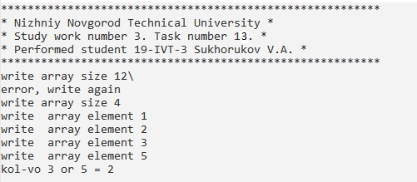

№14

#include <iostream>

#include <vector>

char logo[] = "*********************************************************\n"

"* Nizhniy Novgorod Technical University *\n"

"* Study work number 3. Task number 14. *\n"

"* Performed student 19-IVT-3 Sukhorukov V.A. *\n"

"*********************************************************\n";

using namespace std;

int main()

{

cout << logo;

int n = proverkaN(), k = 0;

vector<int> a(n);

for (int i = 0; i < n; i++) {

cout << "write array element ";

cin >> a[i];

if (a[i] >=4 && a[i] <= 7) {

k++;

}

}

cout << "kol-vo a[i] >=4 && a[i] <= 7 = " << k << endl;

return 0;

}

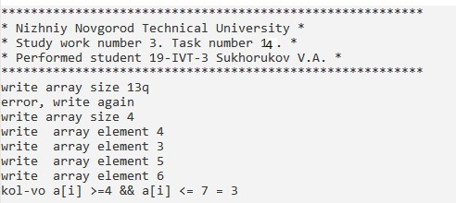

№15

#include <iostream>

#include <vector>

char logo[] = "*********************************************************\n"

"* Nizhniy Novgorod Technical University *\n"

"* Study work number 3. Task number 15. *\n"

"* Performed student 19-IVT-3 Sukhorukov V.A. *\n"

"*********************************************************\n";

using namespace std;

int main()

{

cout << logo;

int n = proverkaN(), k = 0;

vector<int> a(n);

for (int i = 0; i < n; i++) {

cout << "write array element ";

cin >> a[i];

if (a[i] >=5 ) {

k++;

}

}

cout << "kol-vo a[i] >=5 = " << k << endl;

return 0;

}

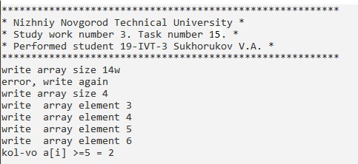

№16

#include <iostream>

#include <vector>

char logo[] = "*********************************************************\n"

"* Nizhniy Novgorod Technical University *\n"

"* Study work number 3. Task number 16. *\n"

"* Performed student 19-IVT-3 Sukhorukov V.A. *\n"

"*********************************************************\n";

using namespace std;

int main()

{

cout << logo;

int n = proverkaN(), k = 0;

vector<int> a(n);

for (int i = 0; i < n; i++) {

cout << "write array element ";

cin >> a[i];

if (a[i] == 0 &&(i+1)%2==1) {

k++;

}

}

cout << "kol-vo a[i] == 0 &&(i+1)%2==1 " << k << endl;

return 0;

}

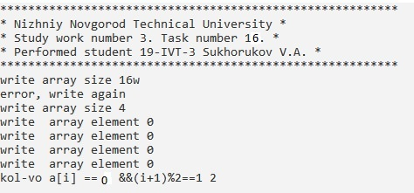

№17

#include <iostream>

#include <vector>

char logo[] = "*********************************************************\n"

"* Nizhniy Novgorod Technical University *\n"

"* Study work number 3. Task number 17. *\n"

"* Performed student 19-IVT-3 Sukhorukov V.A. *\n"

"*********************************************************\n";

using namespace std;

int main()

{

cout << logo;

int n = proverkaN(), s = 0;

vector<int> a(n);

for (int i = 0; i < n; i++) {

cout << "write array element ";

cin >> a[i];

if (a[i]>=5) {

s = s + a[i];

}

}

cout << "sum a[i]>=5 = " << s << endl;

return 0;

}

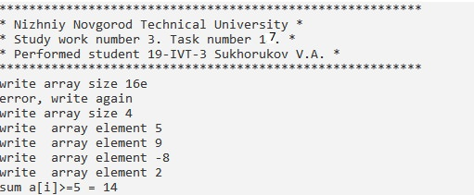

№18

#include <iostream>

#include <vector>

char logo[] = "*********************************************************\n"

"* Nizhniy Novgorod Technical University *\n"

"* Study work number 3. Task number 18. *\n"

"* Performed student 19-IVT-3 Sukhorukov V.A. *\n"

"*********************************************************\n";

using namespace std;

int main()

{

cout << logo;

int n = proverkaN(), p = 1;

vector<int> a(n);

for (int i = 0; i < n; i++) {

cout << "write array element ";

cin >> a[i];

p = p * a[i];

}

p = (p / a[0]) / a[n - 1];

cout << "proizvedenie bez pervogo i poclednego " << p << endl;

return 0;

}

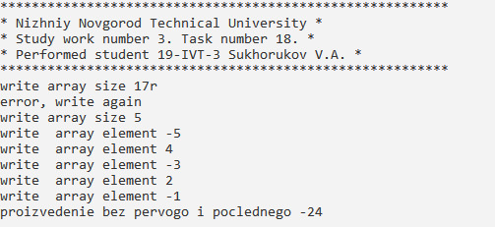

№19

#include <iostream>

#include <vector>

char logo[] = "*********************************************************\n"

"* Nizhniy Novgorod Technical University *\n"

"* Study work number 3. Task number 19. *\n"

"* Performed student 19-IVT-3 Sukhorukov V.A. *\n"

"*********************************************************\n";

using namespace std;

int main()

{

cout << logo;

int n = proverkaN(), k = 0;

vector<int> a(n);

for (int i = 0; i < n; i++) {

cout << "write array element ";

cin >> a[i];

if (a[i]==1 && (i+1)%2==1)

{

k++;

}

}

cout << "kol-vo edinich na nechetnih = " << k << endl;

return 0;

}

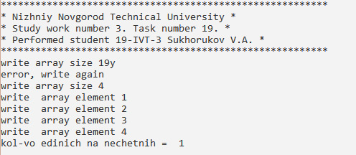

№20

#include <iostream>

#include <vector>

char logo[] = "*********************************************************\n"

"* Nizhniy Novgorod Technical University *\n"

"* Study work number 3. Task number 20. *\n"

"* Performed student 19-IVT-3 Sukhorukov V.A. *\n"

"*********************************************************\n";

using namespace std;

int main()

{

cout << logo;

int n = proverkaN(), s = 0;

vector<int> a(n);

for (int i = 0; i < n; i++) {

cout << "write array element ";

cin >> a[i];

if (a[i] <=0 && (i + 1) % 2 == 1)

{

s=s+a[i];

}

}

cout << "summa otrichatelnih na nechetnih = " << s << endl;

return 0;

}

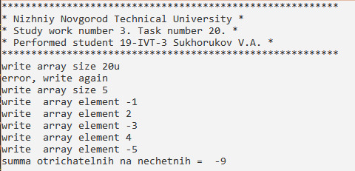

№21

#include <iostream>

#include <vector>

char logo[] = "*********************************************************\n"

"* Nizhniy Novgorod Technical University *\n"

"* Study work number 3. Task number 21. *\n"

"* Performed student 19-IVT-3 Sukhorukov V.A. *\n"

"*********************************************************\n";

using namespace std;

int main()

{

cout << logo;

int n = proverkaN(), p = 1;

vector<int> a(n);

for (int i = 0; i < n; i++) {

cout << "write array element ";

cin >> a[i];

if (a[i] != 0 )

{

p = p * a[i];

}

}

cout << "proizvedenie ne nulevih = " << p << endl;

return 0;

}

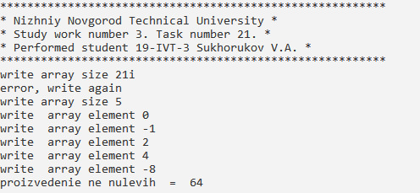

№22

#include <iostream>

#include <vector>

char logo[] = "*********************************************************\n"

"* Nizhniy Novgorod Technical University *\n"

"* Study work number 3. Task number 22. *\n"

"* Performed student 19-IVT-3 Sukhorukov V.A. *\n"

"*********************************************************\n";

using namespace std;

int main()

{

cout << logo;

int n = proverkaN(),aMin,aMax,iMax=0,iMin=0;

vector<int> a(n);

cout << "write array element ";

cin >> a[0];

aMin = a[0];

aMax = a[0];

for (int i = 1; i < n; i++) {

cout << "write array element ";

cin >> a[i];

if (a[i] > aMax) {

aMax = a[i];

iMax = i;

}

if (a[i] < aMin) {

aMin = a[i];

iMin = i;

}

}

swap(a[iMin], a[iMax]);

for (int i = 0; i < n; i++) { cout << a[i] << endl; }

return 0;

}

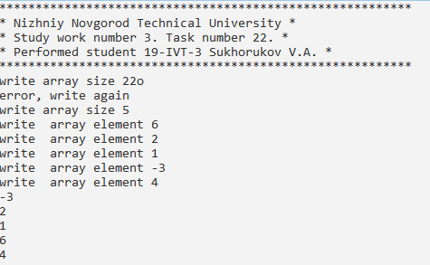

№23

#include <iostream>

#include <vector>

char logo[] = "*********************************************************\n"

"* Nizhniy Novgorod Technical University *\n"

"* Study work number 3. Task number 23. *\n"

"* Performed student 19-IVT-3 Sukhorukov V.A. *\n"

"*********************************************************\n";

using namespace std;

int main()

{

cout << logo;

int n = proverkaN(), aMin, iMin = 0,j=0,s=0;

vector<int> a(n);

cout << "write array element ";

cin >> a[0];

aMin = a[0];

for (int i = 1; i < n; i++) {

cout << "write array element ";

cin >> a[i];

if (a[i] < aMin) {

aMin = a[i];

iMin = i;

}

}

while (a[j] != 0) {

if (a[j] > 0) {

s = s + a[j];

}

j++;

}

a[iMin] = s;

for (int i = 0; i < n; i++) { cout << a[i] << endl; }

return 0;

}

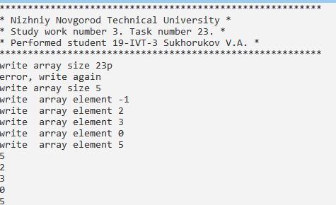

№24

#include <iostream>

#include <vector>

char logo[] = "*********************************************************\n"

"* Nizhniy Novgorod Technical University *\n"

"* Study work number 3. Task number 24. *\n"

"* Performed student 19-IVT-3 Sukhorukov V.A. *\n"

"*********************************************************\n";

using namespace std;

int main()

{

cout << logo;

int n = proverkaN(), aMin, iMin = 0,j=0;

vector<int> a(n);

cout << "write array element ";

cin >> a[0];

aMin = a[0];

for (int i = 1; i < n; i++) {

cout << "write array element ";

cin >> a[i];

if (a[i] < aMin) {

aMin = a[i];

iMin = i;

}

}

while (a[j] <= 0) {j++;}

swap(a[iMin] , a[j]);

for (int i = 0; i < n; i++) { cout << a[i] << endl; }

return 0;

}

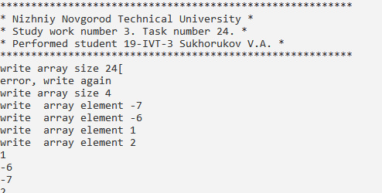

№25

#include <iostream>

#include <vector>

char logo[] = "*********************************************************\n"

"* Nizhniy Novgorod Technical University *\n"

"* Study work number 3. Task number 25. *\n"

"* Performed student 19-IVT-3 Sukhorukov V.A. *\n"

"*********************************************************\n";

using namespace std;

int main()

{

cout << logo;

int n = proverkaN(), aMax, iMax = 0;

vector<int> a(n);

cout << "write array element ";

cin >> a[0];

aMax = a[0];

for (int i = 1; i < n; i++) {

cout << "write array element ";

cin >> a[i];

if (a[i] > aMax) {

aMax = a[i];

iMax = i;

}

}

for (int i = 0; i < iMax; i++)

{

if (a[i]<0)

{

a[i] = 0;

}

}

for (int i = 0; i < n; i++) { cout << a[i] << endl; }

return 0;

}

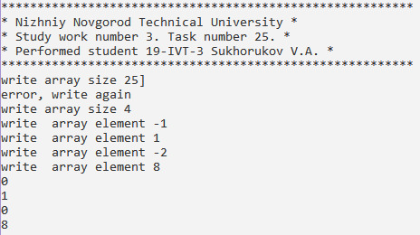

№26

#include <iostream>

#include <vector>

char logo[] = "*********************************************************\n"

"* Nizhniy Novgorod Technical University *\n"

"* Study work number 3. Task number 26. *\n"

"* Performed student 19-IVT-3 Sukhorukov V.A. *\n"

"*********************************************************\n";

using namespace std;

int main()

{

cout << logo;

int n = proverkaN(), aMin, iMin = 0;

vector<int> a(n);

cout << "write array element ";

cin >> a[0];

aMin = a[0];

for (int i = 1; i < n; i++) {

cout << "write array element ";

cin >> a[i];

if (a[i] < aMin) {

aMin = a[i];

iMin = i;

}

}

vector<int>b(iMin + 1);

for (int i = 0; i <= iMin; i++) {b[i] = a[i];}

cout << "new array : "<<endl;

for (int i = 0; i < iMin + 1; i++) { cout << b[i] << endl; }

return 0;

}

